UX wireframes:

1. Landing Page

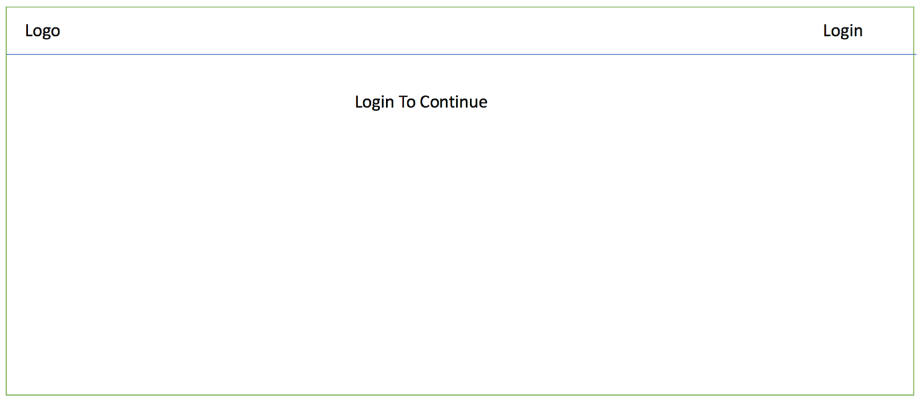

1. Login screen: Redirected to Google Login
2. Logged in page

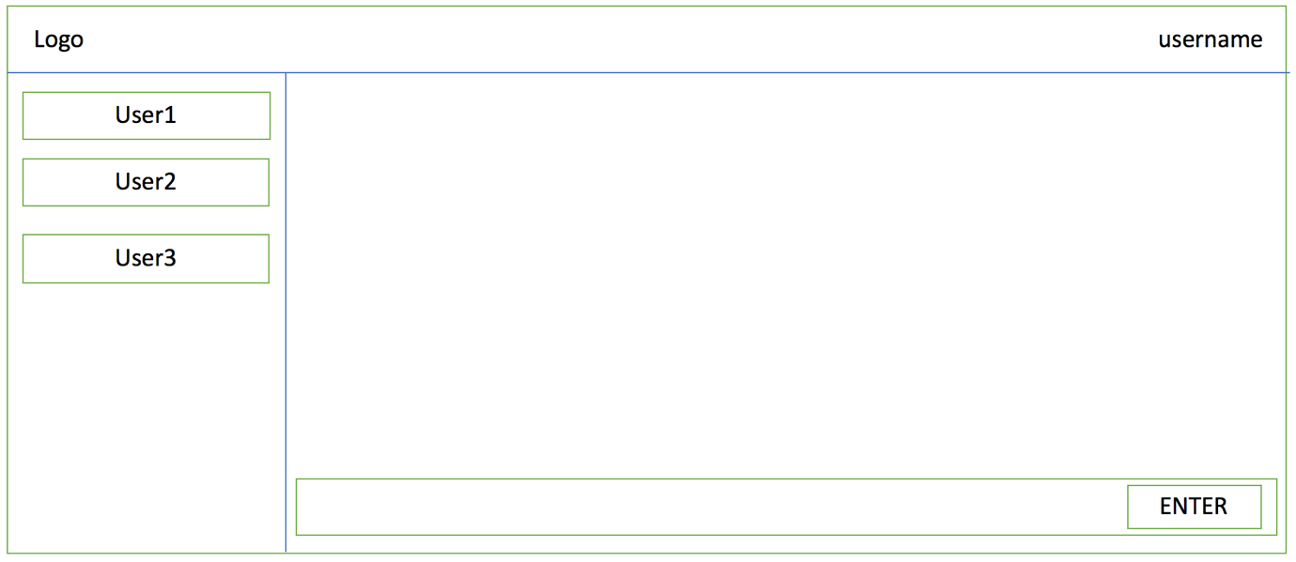

1. Create Repo Form:

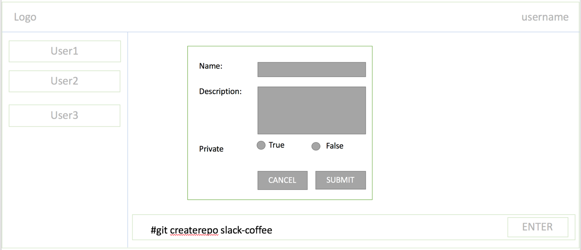

1. Add users as collaborators form:

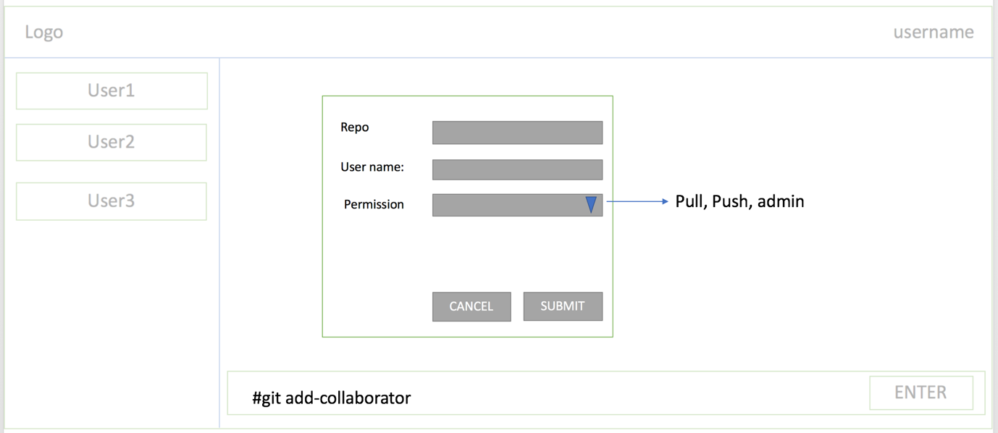

1. Create Issues Form

